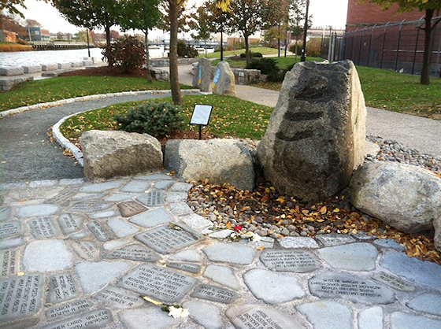

REMEMBRANCE GARDEN
STONE WALKWAY ENGRAVING REQUEST FORM

Name _____________________________________________________________

Address____________________________________________________________

City ____________________________________ State ______ ZIP ____________

Tel. No_____________________________________________________________

Email Address _______________________________________________________

Please clearly print your child’s name as you would like it to be engraved for the stone walkway:

CHILD’S NAME ______________________________________________________

Please enclose a check for $50, made payable to:
Remembrance Garden Greater Providence

Mail your check to:
Lucille Valliere, Chapter Leader
10 Dail Drive
North Providence, RI 02911

Any questions, please call Lucille at 401-231-9229.

